Rondo Form Composition

Grade Span: 5-8 Grade Level: 5

Discipline: Music Assessment Type: Simulation
Purpose: Summative

Title of Unit(s): Help Me Rondo

Maine Learning Results:

Standard: (include all standards and performance indicators being assessed):
Visual and Performing Arts: A3, A4, A5, A9, C6
Science and Technology: L6

Performance Indicators:

MLR – VPA Standard A3 – Students identify and read musical notation
MLR – VPA Standard A2 – Students read and identify musical notation, symbols and terminology of dynamics.
MLR – VPA Standard A5 – Investigate the work of a professional who has an arts component within his/her work environment.
MLR – VPA Standard A9 – Develop skill in playing an instrument and/or singing and reading music.
MLR – VPA Standard E5 – Students identify and demonstrate the positive interpersonal skills necessary to get along with others and participate in the arts.

Assessment Summary:

Students will create a written musical composition in Rondo form (ABACA) that utilizes the elements of notation. Students will discriminate among qualities of intervals of sound for a musical composition. Students will hand write their original piece. Investigation of a composer’s work through auditory discovery and visual score reading will enhance their assessment. Students will develop skill in singing and/or playing their completed piece. Students will use a group scoring rubric to critique their own work and the work of others.

Materials and Resources:
- Composition paper
- Rulers
- Pencils
- Xylophones
- Orchestra scores and Cds
- Lesson Rubric
- Group Scoring Rubric

Suggested Timeframe: 3 weeks

Suggestions for Prior Instruction:
- Unit on Form
- Notation review
- Note name review
- Instrument handling review

Extension (opportunity is built in to extend or demonstrate sophistication in order to reach a rubric score of four):
- Composition can use more sophisticated elements.
- Student can further research composer(s) for information and ideas.
- Student can practice performance outside of the class.
- Student can assist others in group or other groups in development of sections.
- Composition can add harmony to the basic melody.
- Student can transcribe the hand written music into a software notation program.

Source of Original Assessment:
Locally developed.

Date Successfully Piloted: Spring 2004
Date the assessment was created or updated: Spring 2003

Updated by CCC May 17, 2004
Teacher Notes for Rondo Form Assessment

Provide each student with a packet that contains the following:
- Rondo form Worksheet
- Rondo Form Lesson Rubric
- Self and Peer Evaluation Rubric

Review note values and rest values on bottom of worksheet
Review Vocabulary:
treble clef
bar line
measure
double bar line
dynamics
time signature

Students will use their worksheet to generate their own 4 measure composition.
Partners will choose the time signature and agree to all use the same one.
Students may use a xylophone to hear their melody and experiment with tones.
Caution students about using complicated rhythms – keep playback in mind.
Remind students that they should use the K.I.S.S. method – Keep It Simple, Silly
Remind them to refer to the rubric as they work.
Only notes from Middle C to Treble C should be allowed for ease of playback on xylophones.
No sharps, flats, naturals as the xylophones are diatonic.
Legibility should be enforced. Manuscript will be played in its’ entirety and must match the worksheets exactly.
Worksheets will be approved by the teacher for accuracy and to see if all guidelines are being followed. Offer helpful suggestions to improve.
Any changes to the four measures on the worksheet must be approved and initialed.
Final copies may be started once the sections have been approved.
All sections must be complete and final manuscripts done before performance.
Performance should be done with only the group and teacher. It does not have to be performed in a continuous piece, but may be performed one section at a time.

Performance Scoring will be based on the following rubric:
4 – Completely correct: rhythms, steady beat, notes
3.5 – One of the above areas was lacking.
3 – Two areas were lacking or one area was lacking and there was a single wrong note or rhythm.
2 – Some combination of Two areas and a single wrong note or rhythm
1 – All areas were lacking.

Rondo Form

Student Checklist

- Did I listen to the “Help Me Rondo” music? Did I choose to take this part further?
- Does my section have different rhythms and tones from my partners?
- Did I get my 4 measures approved?
- Is my final composition in Rondo form?
- Does my final composition have at least 5 of these elements?
  - treble clef on every staff
  - time signature at the beginning
  - double bar line at the end
  - 4 measures in each part
  - the correct number of beats in each measure
  - dynamics
  - ends on the note C
- Can I perform my own section with no more than one mistake?
- Did I complete the peer cooperation rubric fairly and in a timely manner?

Self and Peer Cooperation Rubric

Students will use a peer cooperation rubric as follows:

Partners,  Names and  Sections: | Participated in all activities | Cooperated with team members | Assisted team in final presentation | Completed all required forms
Self:

Section composed: ___
Partner 1:

Section composed: ___
Partner 2:

Section composed: ___

Score yourself and your partners on the rubric using the following scale:
4 – All the time
3 – Most of the time
2 – Some of the time
1 – Hardly at all

Additional comments for improvement of self and/or others:

Music Technology Websites and Downloads

Your music can be notated and played back through this Free Download (either in Windows or Mac).
This software does have some limitations, however.

Finale Notepad 2005 - Free Download
Music Notation Software
http://www.finalemusic.com/notepad

If you become serious about notating your own music, you should look into purchasing one of the proven programs below:

Finale Make Music
http://www.finalemusic.com

Sibelius
http://www.sibelius.com/cgi-bin/home/home.pl

These two programs are used by composers all over the world, and they are fairly expensive. If you need help with them,
please contact Ms. Packales.

bpackales@msad11.org

There are other programs that allow you to generate music for playback that is not completely original. They are sequencing programs. Some of these are:

Garage Band
Band in a Box

Rondo Form Lesson Rubric

Standards Based Criteria | Doesn’t Meet Standard  (1) | Partially Meets Standard  (2) | Meets Standard  (3) | Exceeds  Standard  (4)
MLR – VPA Standard A3 – Disciplinary Literacy | Has 3 very similar sections (A, B & C) both rhythmically and tonally. | Has 3 somewhat similar sections (A, B & C) either rhythmically or tonally. | Has 3 different sections (A, B & C) both rhythmically and tonally. | Has 3 distinctly different sections (A, B & C) both rhythmically and tonally.
MLR – VPA Standard A2 – Disciplinary Literacy | Composition contains at least 3 of the following elements – treble clef, double bar line, dynamics, 4 measures in each section, correct number of beats in each measure, time signature, and ends on the note ‘C’. | Composition contains at least 4 of the following elements – treble clef, double bar line, dynamics, 4 measures in each section, correct number of beats in each measure, time signature, and ends on the note ‘C’. | Composition contains at least 5 of the following elements – treble clef, double bar line, dynamics, 4 measures in each section, correct number of beats in each measure, time signature, and ends on the note ‘C’. | Composition contains at least 6 of the following elements – treble clef, double bar line, dynamics, 4 measures in each section, correct number of beats in each measure, time signature, and ends on the note ‘C’.
MLR – VPA Standard B2 – Create, Perform, Express | Performs own section with more than three mistakes. | Performs own section with no more than two mistakes. | Performs own section with one mistake. | Performs own section with no mistakes.
MLR – VPA Standard E5 – Interpersonal Skills | Does not complete the peer cooperation rubric for self and others and/0r did not accept a role and/or did not complete assigned tasks. | Partially completes the peer cooperation rubric for self and others and/or partially completed assigned tasks. Provides a partial journal. | Completes the peer cooperation rubric for self and others and accepted a role and completed assigned tasks. Provides daily journal as backup for scores. | Completes the peer cooperation rubric and adds constructive comments. Also accepted a role and completed assigned tasks while assisting others to complete theirs.

Total Possible Points: 16
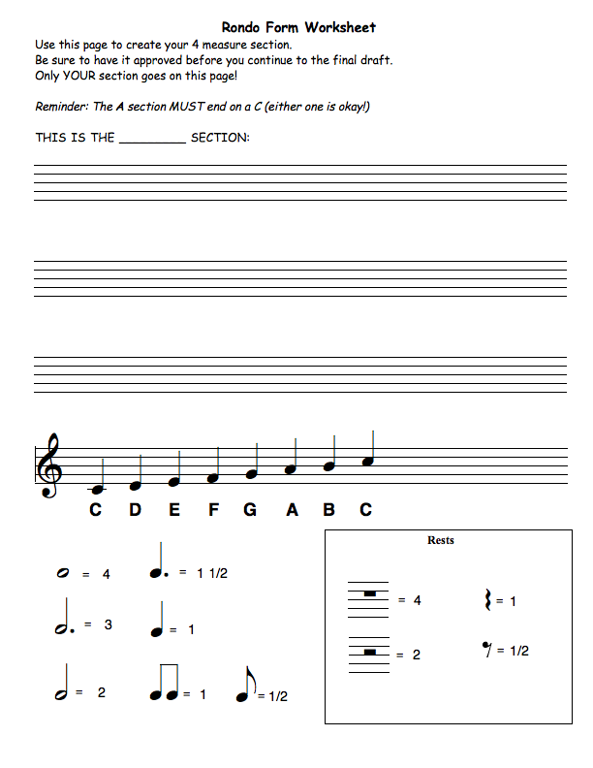
Name: ________________________________________ Class:____________________

Final Manuscript

